# SMART SECURITY ALERT SYSTEM

**A PROJECT REPORT**

***Submitted by***

**AMIT KUMAR SAMAL**

***In partial fulfillment for award of the degree***

***of***

**MASTER OF COMPUTER APPLICATION**



**SCHOOL OF ENGINEERING AND TECHNOLOGYBHUBANESWAR CAMPUS**

**CENTURION UNIVERSITY OF TECHNOLOGY AND MANAGEMENT ODISHA**

**AUGUST 2023 / JANUARY 2024**

## SPECIMEN CERTIFICATE

**DEPARTMENT OF MASTER OF COMPUTER APPLICATION**

**SCHOOL OF ENGINEERING AND TECHNOLOGY**

**BHUBANESWAR CAMPUS**

**BONAFIDE CERTIFICATE**

Certified that this project report **SMART SECURITY ALERT SYSTEM is** the bonafide work of **“AMIT KUMAR SAMAL”** who

carried out the project work under my supervision. This is to further certify to the best of my knowledge that this project has not been carried out earlier in this institute and the university.

**SIGNATURE**

**(Dr. Adyasha Swain)**

**(Assistant Professor of MCA**

*Certified that the above mentioned project has been duly carried out as per the norms of the college and statutes of the university.*

**SIGNATURE**

**(Dr. Rakesh Kumar Ray)**

**HEAD OF THE DEPARTMENT**

**HOD of Master of computer Application**

DEPARTMENT SEAL

## DECLARATION

I hereby declare that the project entitled “**SMART SECURITY ALERT SYSTEM**” submitted for the “Minor Project” of 1ST semester in Master of Computer Application is my original work and the project has not formed the basis for the award of any Degree / Diploma or any other similar titles in any other University / Institute.

**Name of the Students: AMIT KUMAR SAMAL**

**Signature of the Students:**

**Registration No: 230720100157**

**Place: Bhubaneswar**

**Date:**

## 

## ACKNOWLEDGEMENTS

We wish to express our profound and sincere gratitude to Dr.

Adyasha Swain, Department of Master of Computer Application, SoET, Bhubaneswar Campus, who guided me into the intricacies of this project nonchalantly with matchless magnanimity.

I thank Dr. Rakesh Kumar Ray, Head of the Dept. of Master of Computer Application, SoET, Bhubaneswar Campus and Dr. Sujata Chakravarty, Dean, School of Engineering and Technology, Bhubaneswar Campus for extending their support during Course of this investigation.

I would be failing in my duty if I don’t acknowledge the cooperation rendered during various stages of image interpretation by Dr. Adyasha Swain.

I am highly grateful to Dr. Adyasha Swain who evinced keen interest and invaluable support in the progress and successful completion of my project work.

I am indebted to Dr. Ayasha Swain for their constant encouragement, co- operation and help. Words of gratitude are not enough to describe the accommodation and fortitude which they have shown throughout my endeavor.

**Name of the Student:**

**Signature of the Student:**

**Registration No.: 230720100157**

**Place: BBSR**

**Date:**

**TABLE OF CONTENTS**

1. **INTRODUCTION**
2. **RELATED WORK**
3. **METHODOLOGY**
4. **OBJECTIVE**
5. **NETWORK DIAGRAM**
6. **CONCLUSION**
7. **REFERENCE**

**ABSTRACT**

The technology has been growing from day to day in human life. The necessity for the development of technology is to lead human life comfortably. The basic need of human to lead his/her life comfortably is a home. A home with updated latest technology which means a smart home. This paper gives the basic idea use cisco packet tracer to implement smart home. One is needed to create a smart home when electronic devices are switched on and off. Smart home development is achieved by simulation via testing system, network setup and wireless home gateway computer network equipment required by a smart home network cisco packet tracer using Internet Thing (IoT)/IoE command. The software chosen for the simulations is Cisco Packet Tracer, the tool's main strength is to offer a variety of network components that represent a real network, and then interconnect and configure devices to create a network. Cisco implemented (IoT) functionalities in the latest version of the platform, and now it is possible to add all the smart devices, sensors, actuators and also devices, which simulate microcontrollers like Arduino or Raspberry Pi to the network. All IoT devices can be run on generic programs or modified by Java, Python or Blocky programming them. This makes Cisco Packet Tracer a perfect method to construct functional simulations for IoT.

The advancement in the Internet of Things for electronic devices and applications has attracted people, especially younger generations, to move into the interconnected world. A smart home is an example of an application that is highly in demand. Together with the rise is cybersecurity issues. By being connected, many users are exposed to security threats without their knowledge. This paper presents a security analysis on the smart home environment using Packet Tracer Simulation Software. A tested of a basic smart home set consisting of electronic appliances, gadgets, and surveillance system is set up in the Cisco Packet Tracer software version 7.1. Possible vulnerabilities issues were simulated at the network and application layers. The vulnerabilities and possible attacks on the smart home network environment were successfully identified. Mitigation techniques on the attack were proposed to reduce the probability of the network attacks.

Index Terms : Internet of Everything, Smart home, packer tracer tool, sensors

**INTRODUCTION**

With the increase of thefts and the speed of their spread , peoples fear and anxiety increased , concern and afraid of being psychologically or physically and by the robber , the developers of computers technologist began to create different and diverse protection systems to protect houses by informing owners that a stranger in their house or alarm them when danger occurs . It is used to design a systematic and well-planned topology, satisfying all the necessities of the office. It come up with a good performance. It is also providing security and authentication to forbid unauthorized logins.

In today's technologically growing world technological development without becoming a requirement that is frequently used in today’s human life. Living home that includes smart objects with specific functions is called smart home. i.e aimed to improve safety, comfort and efficiency . which can be used to automate home activities without users using various sensors (Temperature, Humidity, Smoke, Wind, Sound) to monitor the home environment. And there are usually monitoring tools, and the devices that are controllable and automatic this can be accessed via an internet-connected computer or smart mobile device. Instead of providing security that is safe, smart home can provide different features to provide automatic security using various alarm systems, as LCD display and siren sound and by sending email to valid users if sensor detects security issues . Home automation states handling and monitoring home items using microcontroller or computer technology.  
  
 All smart devices are registered at the home gateway in this paper and operated by a legitimate person. By including different sensors in home automation, Smart Home eliminates user engagement in tracking home settings and operating home appliances. IOT (Internet of Things) is a system in which people, objects with a specific identity and moving capacity information without needing a dual human-to-human origin , i.e. destination or contact between people and computers IoT and IoE are a well versed technology which optimizes the life based on smart sensors and smart devices which operate together on the internet.  
Latest version the simulation program for cisco packet tracer modelling and configuration of IOE systems with conventional networking system to implement smart home.

**Cisco Packet Tracer** -Packet Tracer is a cross-platform visual simulation tool designed by Cisco Systems that allows users to create network topologies and imitate modern computer networks. The software allows users to simulate the configuration of Cisco routers and switches using a simulated command line interface.

**RELATED WORK**

The design of smart of security alarm monitoring based on less (2011): It is based on expert system knowledge , embedded technology and wireless sensor , technology etc. Mainly fire access control system anti-theft subsystem , fire sub-alarm system , gas leak sub-system etc. Less uses an improve version of the algorithm, rete word is highly effective mechanism for solving a difficult matching problem for many of them using the control technology .

Paper presents the design of the security of home by alarming the specific person short message service through global , the main objective of developing this research was to design and develop a home security system that is capable of monitoring any intruders and other emergency situation by alarming the home owners via SMS through GMS modem.

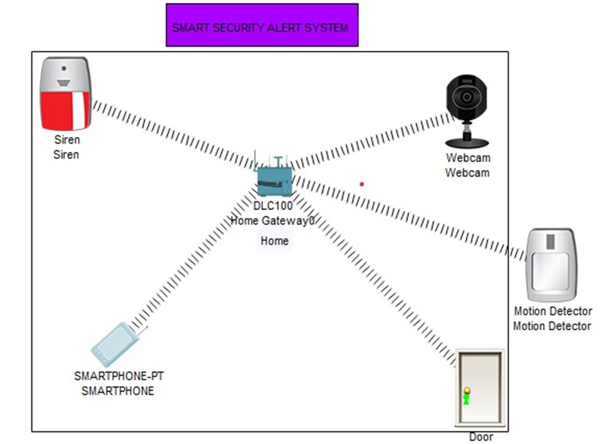

**METHODOLOGY**

The idea of smart is very catchy and review on similar researches was conducted to understand its concepts and its architecture. As implemented by majority of researchers, cisco packet tracer was used for implementing smart home. The newly released cisco version was used as it supports home security features as well as provides programming environment besides networking features. The different programming languages supported are visual basic, java scripts, and python. Laptop and Wireless router are used to control the devices such as smart window, smart fan, smart garbage and sensor. The smart devices are connected to the IOT Wireless router ports and laptop is used to communicate with the smart devices.

**OBJECTIVES**

Establishing a system aimed at providing protection and safety and reduce exposure to common hazards , alert at soon as they occurs .

**NETWORK DIAGRAM**

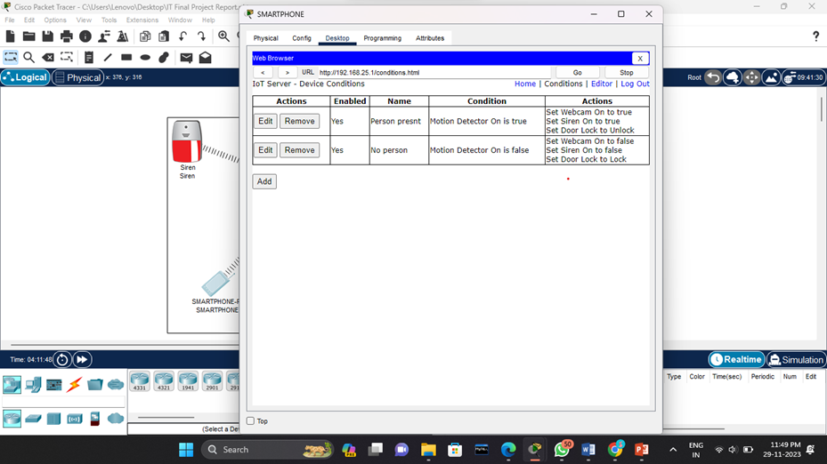

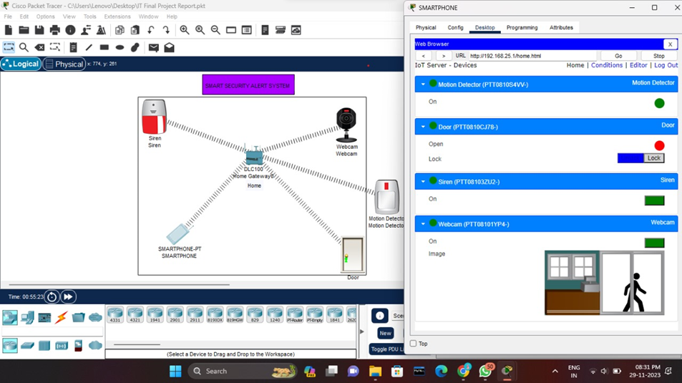

**CONCLUSION**

In this paper it has been seen the prototype model works without any basic error. So it can be implemented in practical field. Beside the cost of the project is not too much. Here it has provided utmost security so it is quite impossible to any burglar to enter the room without concern of owner. If available financial and technical support from the concerned Govt. section and organizations is found, then it will be possible to commercialize the proposed lock for the benefit of the people of our country. Some feature has been added to make the project more efficient. It could be implemented it by GSM based home security system. For this when a burglar enters the room without the concern of owner a sms 14 will be sent to the user. Then he will take precautionary measure. It may be used another technique called biometrics which is more prominent and a recognized means of positive identification. Some new technologies such as fingerprint scanning, retinal scanning and iris scanning, and voiceprint identification also can be inserted. Moreover it could be useful for various sensors such as gas sensor, fire sensor for more improvement of the security of home

**REFERENCE**

* All classes conducted by **Miss Adyasha Swain**
* Google search // You tube.
* 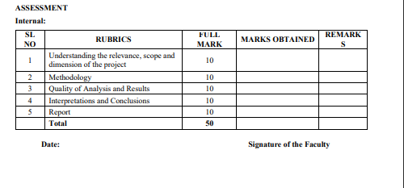[**https://youtu.be/42DCkx36Uv8//**](https://youtu.be/42DCkx36Uv8/)

**COURSE OUTCOME (COs) ATTAINMENT**

* **Expected Course Outcomes (COs):**

**(Refer to COs Statement in the Syllabus)**

* Course Outcome Attained:

**How would you rate your learning of the subject based on the specified COs?**



1 2 3 4 5 6 7 8 9 10

#### LOW HIGH

* Learning Gap (if any):

* **Books / Manuals Referred:**

Date: Signature of the Student

* **Suggestions / Recommendations:**

**(By the Course Faculty)**

Date: Signature of the Faculty